Министерство образования Новосибирской области

«ГБПОУ НСО Новосибирский авиационный технический колледж им. Б.С Галущака»

**Практическая работа №4**

Учебная дисциплина: МДК.11.01 Технология разработки и защиты баз данных

Разработал:

студент III курса

группы ПР – 21.101

Портнов М. А.

Проверила:

Еремеева Л. А.

Вариант 18

**CREATE** **TABLE** public.Receipt (

"receiptID" SERIAL **PRIMARY** **KEY**,

"product_code" **VARCHAR**(50) **UNIQUE**,

"product_name" **VARCHAR**(100),

"unit_price" **NUMERIC**(10, 2)

);

**INSERT** **INTO** public.Receipt ("product_code", "product_name", "unit_price")

**VALUES**

(**'A001'**, **'Nike sneakers'**, 120.00),

(**'A002'**, **'Timberland boots'**, 200.00),

(**'A003'**, **'Aldo shoes'**, 150.00),

(**'A004'**, **'Adidas sandals'**, 80.00),

(**'A005'**, **'Dr. Martens boots'**, 180.00),

(**'A006'**, **'Converse sneakers'**, 90.00),

(**'A007'**, **'Crocs sandals'**, 50.00);

**CREATE** **TABLE** public.Sales (

"salesID" SERIAL **PRIMARY** **KEY**,

"sales_date" **DATE**,

"product_code" **VARCHAR**(50),

"product_name" **VARCHAR**(100),

"quantity_sold" **INTEGER**,

"sales_amount" **NUMERIC**(10, 2)

);

**INSERT** **INTO** public.Sales ("sales_date", "product_code", "product_name", "quantity_sold", "sales_amount")

**VALUES**

(**'2024-01-01'**, **'A001'**, **'Nike sneakers'**, 5, 600.00),

(**'2024-01-01'**, **'A002'**, **'Timberland boots'**, 3, 600.00),

(**'2024-01-02'**, **'A003'**, **'Aldo shoes'**, 2, 300.00),

(**'2024-01-03'**, **'A004'**, **'Adidas sandals'**, 4, 320.00),

(**'2024-01-04'**, **'A005'**, **'Dr. Martens boots'**, 1, 180.00),

(**'2024-01-05'**, **'A006'**, **'Converse sneakers'**, 8, 720.00),

(**'2024-01-05'**, **'A007'**, **'Crocs sandals'**, 6, 300.00),

(**'2024-01-06'**, **'A001'**, **'Nike sneakers'**, 2, 240.00),

(**'2024-01-07'**, **'A002'**, **'Timberland boots'**, 1, 200.00),

(**'2024-01-07'**, **'A003'**, **'Aldo shoes'**, 3, 450.00),

(**'2024-01-08'**, **'A004'**, **'Adidas sandals'**, 2, 160.00),

(**'2024-01-08'**, **'A005'**, **'Dr. Martens boots'**, 4, 720.00),

(**'2024-01-09'**, **'A006'**, **'Converse sneakers'**, 5, 450.00),

(**'2024-01-10'**, **'A007'**, **'Crocs sandals'**, 7, 350.00),

(**'2024-01-10'**, **'A001'**, **'Nike sneakers'**, 3, 360.00);

**ALTER** **TABLE** public.Sales

**ADD** **CONSTRAINT** fk_sales_product_code

**FOREIGN** **KEY** ("product_code")

**REFERENCES** public.Receipt ("product_code");

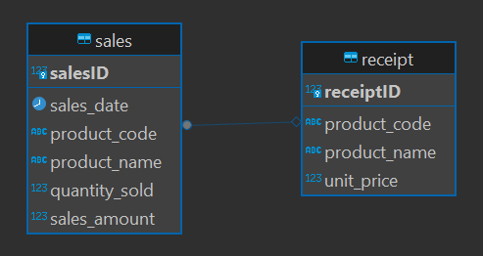

**SELECT** "sales_date", "product_code", "product_name", "quantity_sold", "sales_amount"

**FROM** Sales

**WHERE** "sales_date" = **'2024-01-01'**;

**SELECT** "product_code", "product_name", "unit_price"

**FROM** Receipt

**WHERE** "product_code" = **'A003'**;

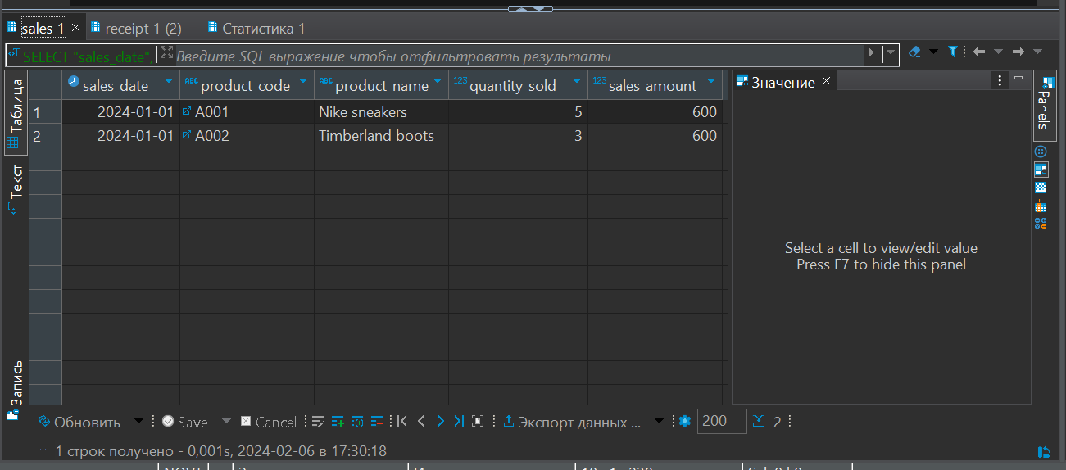

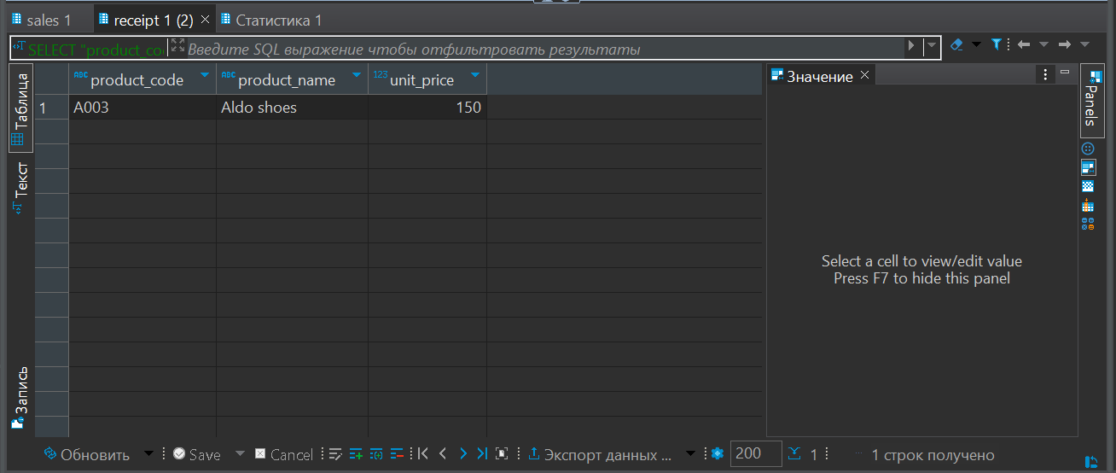

**ALTER** **TABLE** public.sales **ADD** **COLUMN** **sum** **integer**;

**UPDATE** public.sales **SET** sum = quantity_sold * sales_amount;

**SELECT** * **FROM** public.sales

